**Cloudera Search Full Text Search with Solr**

**HDFS NRT Indexer and Search**

**Author: Michelle Zhang**

**Company: Cloudera**

**Date: 10/27/2014**

# Install Cloudera Search Related Components in Cluster

## Install Solr Related Components

After you installed CM, you can use CM “Add a Service” entry to automatically install Solr Related Components.

Base Components: ZooKeeper, HDFS, YARN(MR2 included), HBase

Cloudera Search Need Components: Solr, Flume, Hue

## Start Solr Related Components’ Services

Start Solr related components’ services in sequence with CM:

CM 🡪 Home 🡪 Start Services(Solr, Flume, Hue)

Take CDH 5.2 cluster as an example, and set $HOME=/root/solr, we will introduce how to deploy a NRT(Near Real Time) indexer and search in CDH Cloudera Search.

# Create Collection for HDFS NRT Indexer and Search

## Take Rsyslog as an example.

## Generate Configuration for Collection

Generate the configuration files for the collection:

# solrctl instancedir --generate /root/solr/flume-nrt-syslog

## Prepare Schema.xml for collection

Edit schema.xml in the conf dir to configure Fields, UniqueKey and CopyField:

<fields>

<field name="id" type="string" indexed="true" stored="true" />

<field name="syslog_hostname" type="string" indexed="true" stored="true" />

<field name="syslog_timestamp" type="string" indexed="true" stored="true" />

<field name="syslog_program" type="string" indexed="true" stored="true" />

<field name="syslog_pid" type="int" indexed="true" stored="true" />

<field name="syslog_message" type="string" indexed="true" stored="true" />

<field name="text" type="text_general" indexed="true" stored="true" multiValued="true"/>

<field name="_version_" type="long" indexed="true" stored="true"/>

</fields>

<uniqueKey>id</uniqueKey>

<copyField source="syslog_hostname" dest="text"/>

<copyField source="syslog_timestamp" dest="text"/>

<copyField source="syslog_program" dest="text"/>

<copyField source="syslog_pid" dest="text"/>

<copyField source="syslog_message" dest="text"/>

## Upload Instance Directory to ZooKeeper

# solrctl --zk $ZKHOST:2181/solr instancedir --create flume-nrt-syslog-collection /root/solr/flume-nrt-syslog

## Create New Collection in HDFS

# solrctl --zk $ZKHOST:2181/solr collection --create flume-nrt-syslog-collection -s 3

“-s” means you will use 3 SolrCloud shards, which should correspond to the number of Solr Server instances you have (three in my case)

Then you can verify whether the collection is live in Solr Server Web UI.

For example: <http://ec2-54-68-244-213.us-west-2.compute.amazonaws.com:8983/solr/#/~cloud>

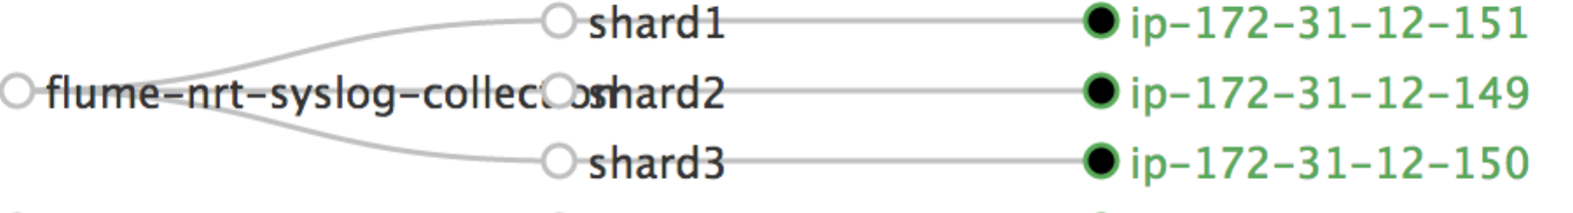

## Configure Flume Sink

Create a single Flume Agent Named "a1" and give it the following configuration.

Using CM , enter Flume🡪 Configuration 🡪 Agent Default Group🡪 Configuration File:

a1.sources = r1

a1.channels = c1

a1.sinks = s1

a1.sources.r1.type = syslogtcp

a1.sources.r1.port = 5144

a1.sources.r1.host = ip-172-31-12-149.us-west-2.compute.internal

a1.sources.r1.keepFields = true

a1.sources.r1.channels = c1

a1.channels.c1.type = memory

a1.sinks.s1.type = org.apache.flume.sink.solr.morphline.MorphlineSolrSink

a1.sinks.s1.channel = c1

a1.sinks.s1.batchSize = 10

a1.sinks.s1.batchDurationMillis = 1000

a1.sinks.s1.morphlineId = **morphline1**

a1.sinks.s1.morphlineFile = **morphlines.conf**

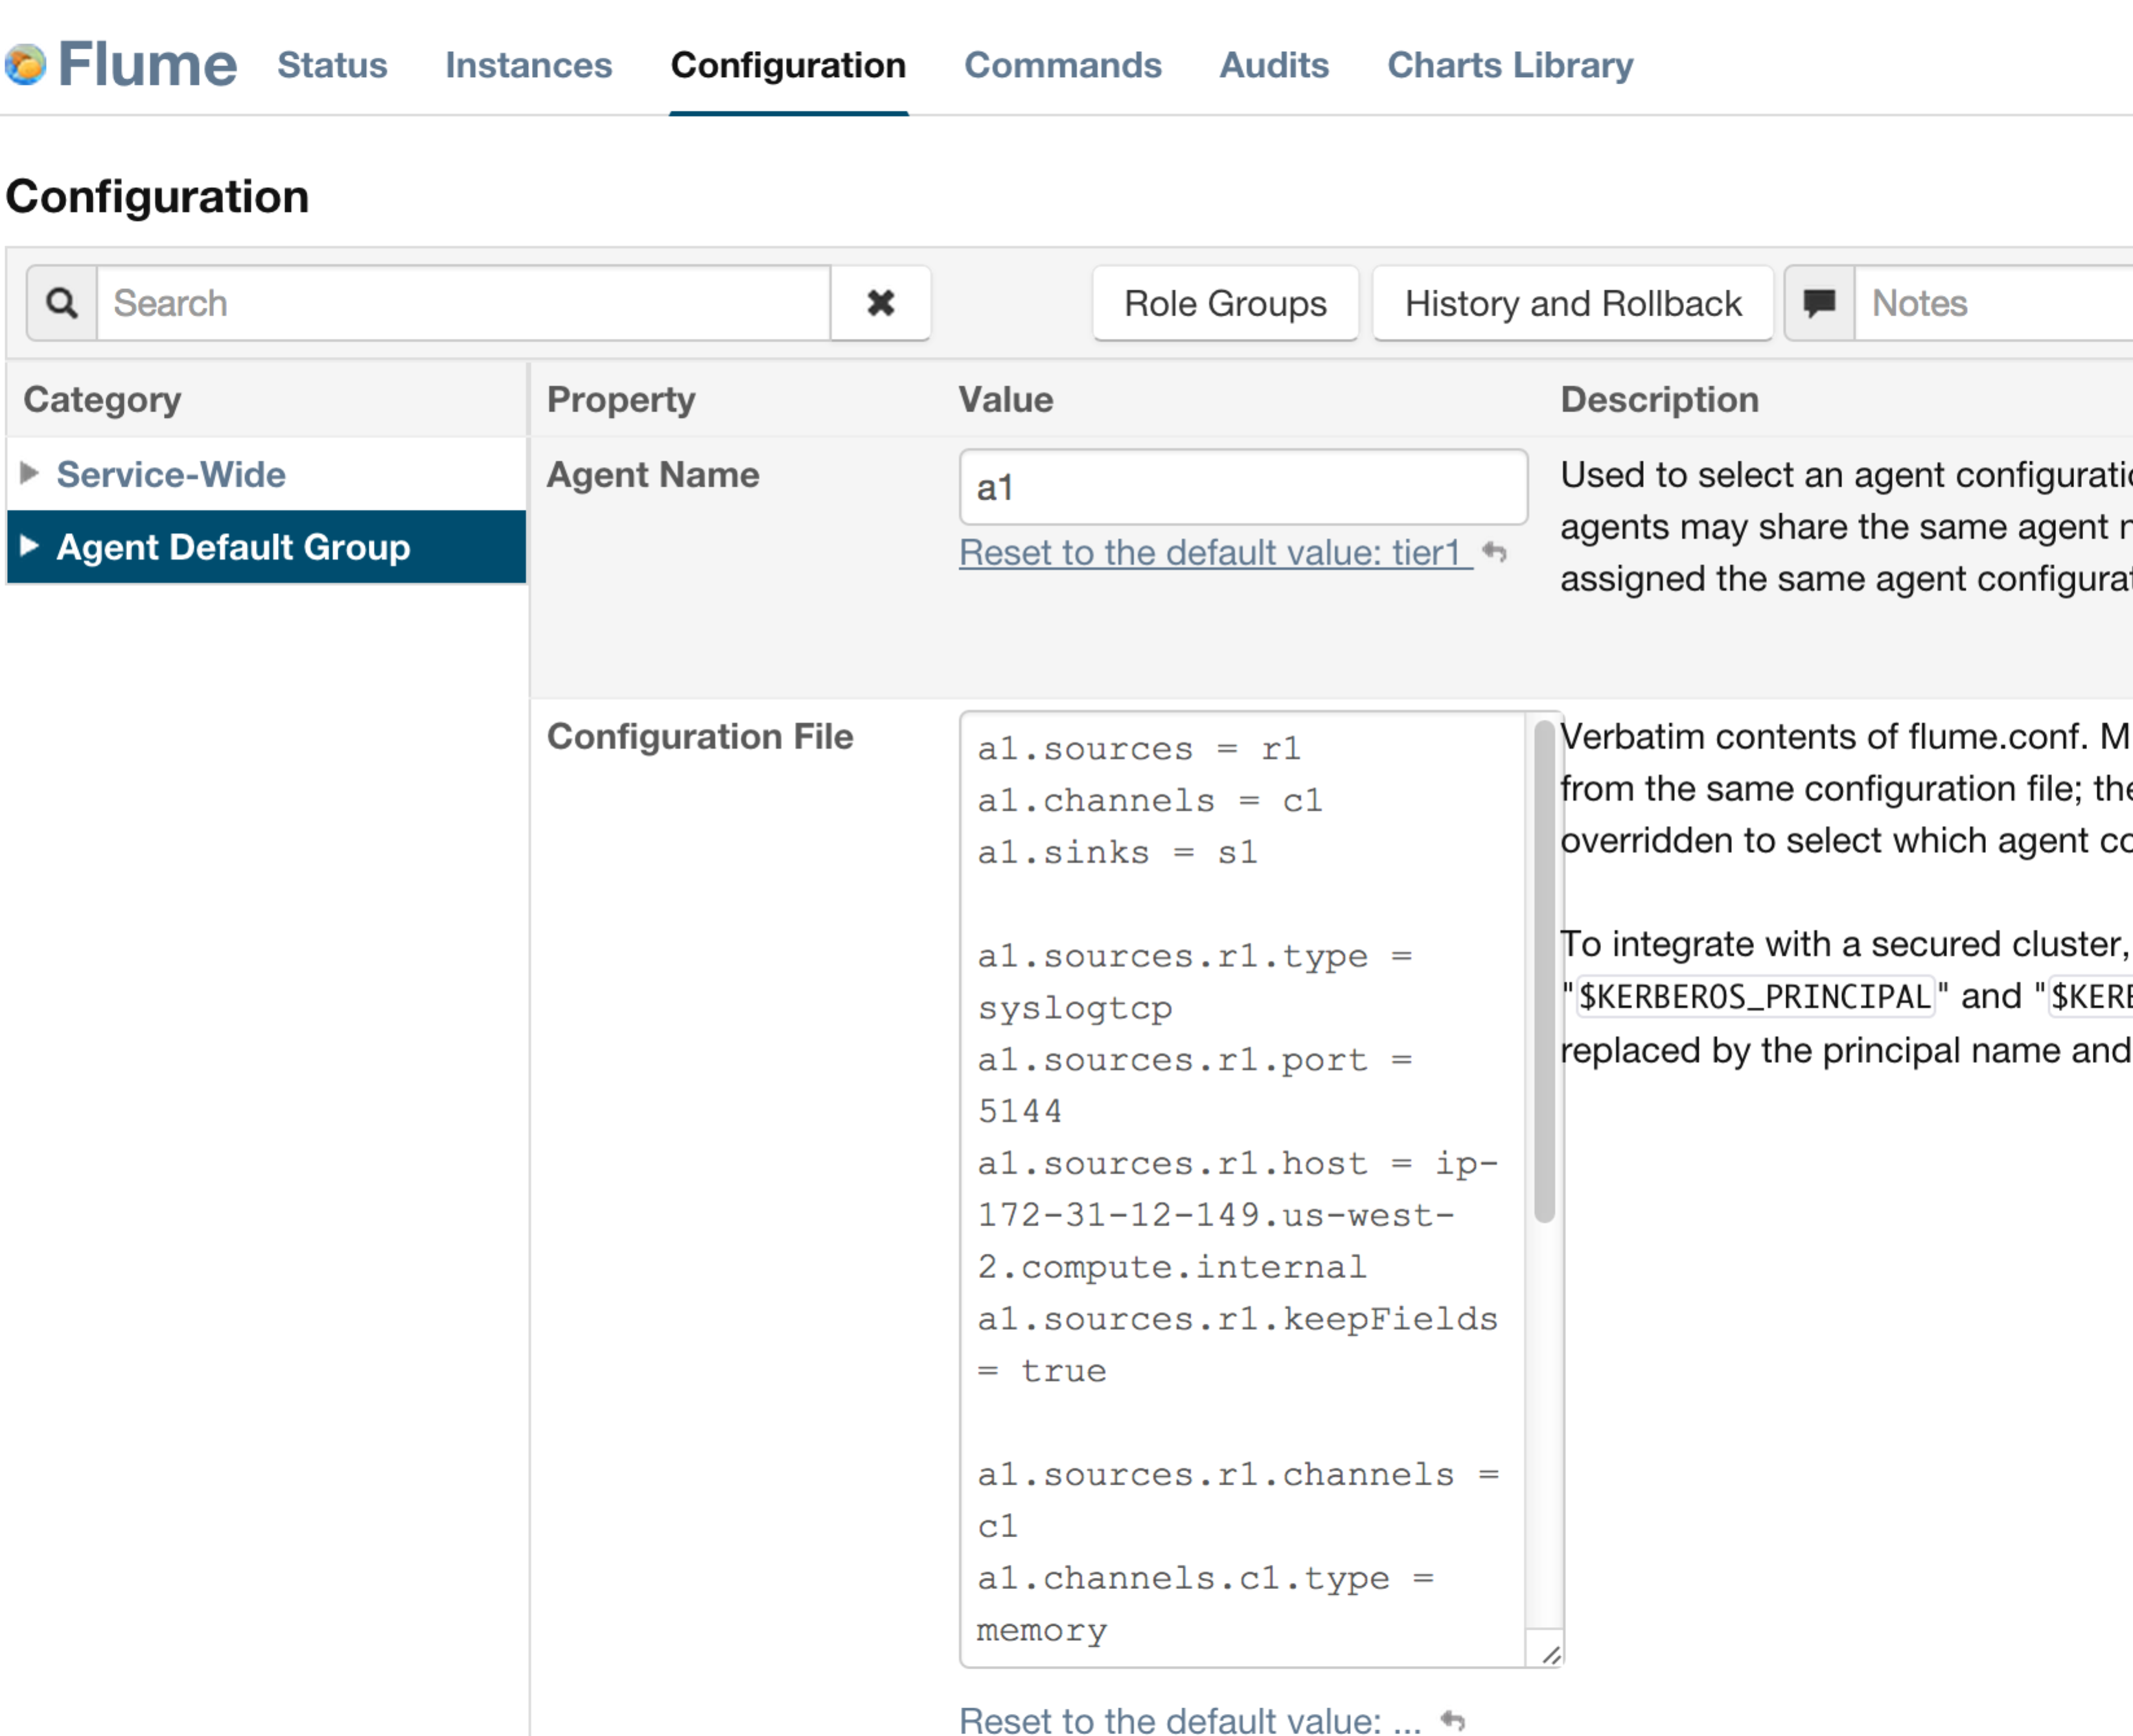

## Configure Morphline

Using CM, enter Flume 🡪 Agent Default Group 🡪 Flume-NG Solr Sink 🡪 Morphlines File:

Flume > Agent > Flume-NG Solr Sink > Morphlines File

SOLR_LOCATOR : {

collection : flume-nrt-syslog-collection

zkHost : "$ZK_HOST"

}

morphlines : [

{

id : morphline1

importCommands : ["org.kitesdk.**","org.apache.solr.**"]

commands : [

## Read each rsyslog line

{ readLine { charset : UTF-8 }}

## parse the message and extract the fields we want

{ grok

{ dictionaryFiles : [grok-dictionary.conf]

expressions : {

message : """<%{POSINT:syslog_pri}>%{SYSLOGTIMESTAMP:syslog_timestamp} %{SYSLOGHOST:syslog_hostname} %{DATA:syslog_program}(?:\[%{POSINT:syslog_pid}\])?: %{GREEDYDATA:syslog_message}"""

}

}

}

## Generate a unique id for each record

{ generateUUID { field : id } }

## Discard fields we don't care about

{ sanitizeUnknownSolrFields { solrLocator : ${SOLR_LOCATOR} } }

## Update the Solr Index

{ loadSolr { solrLocator : ${SOLR_LOCATOR} } }

]

}

]

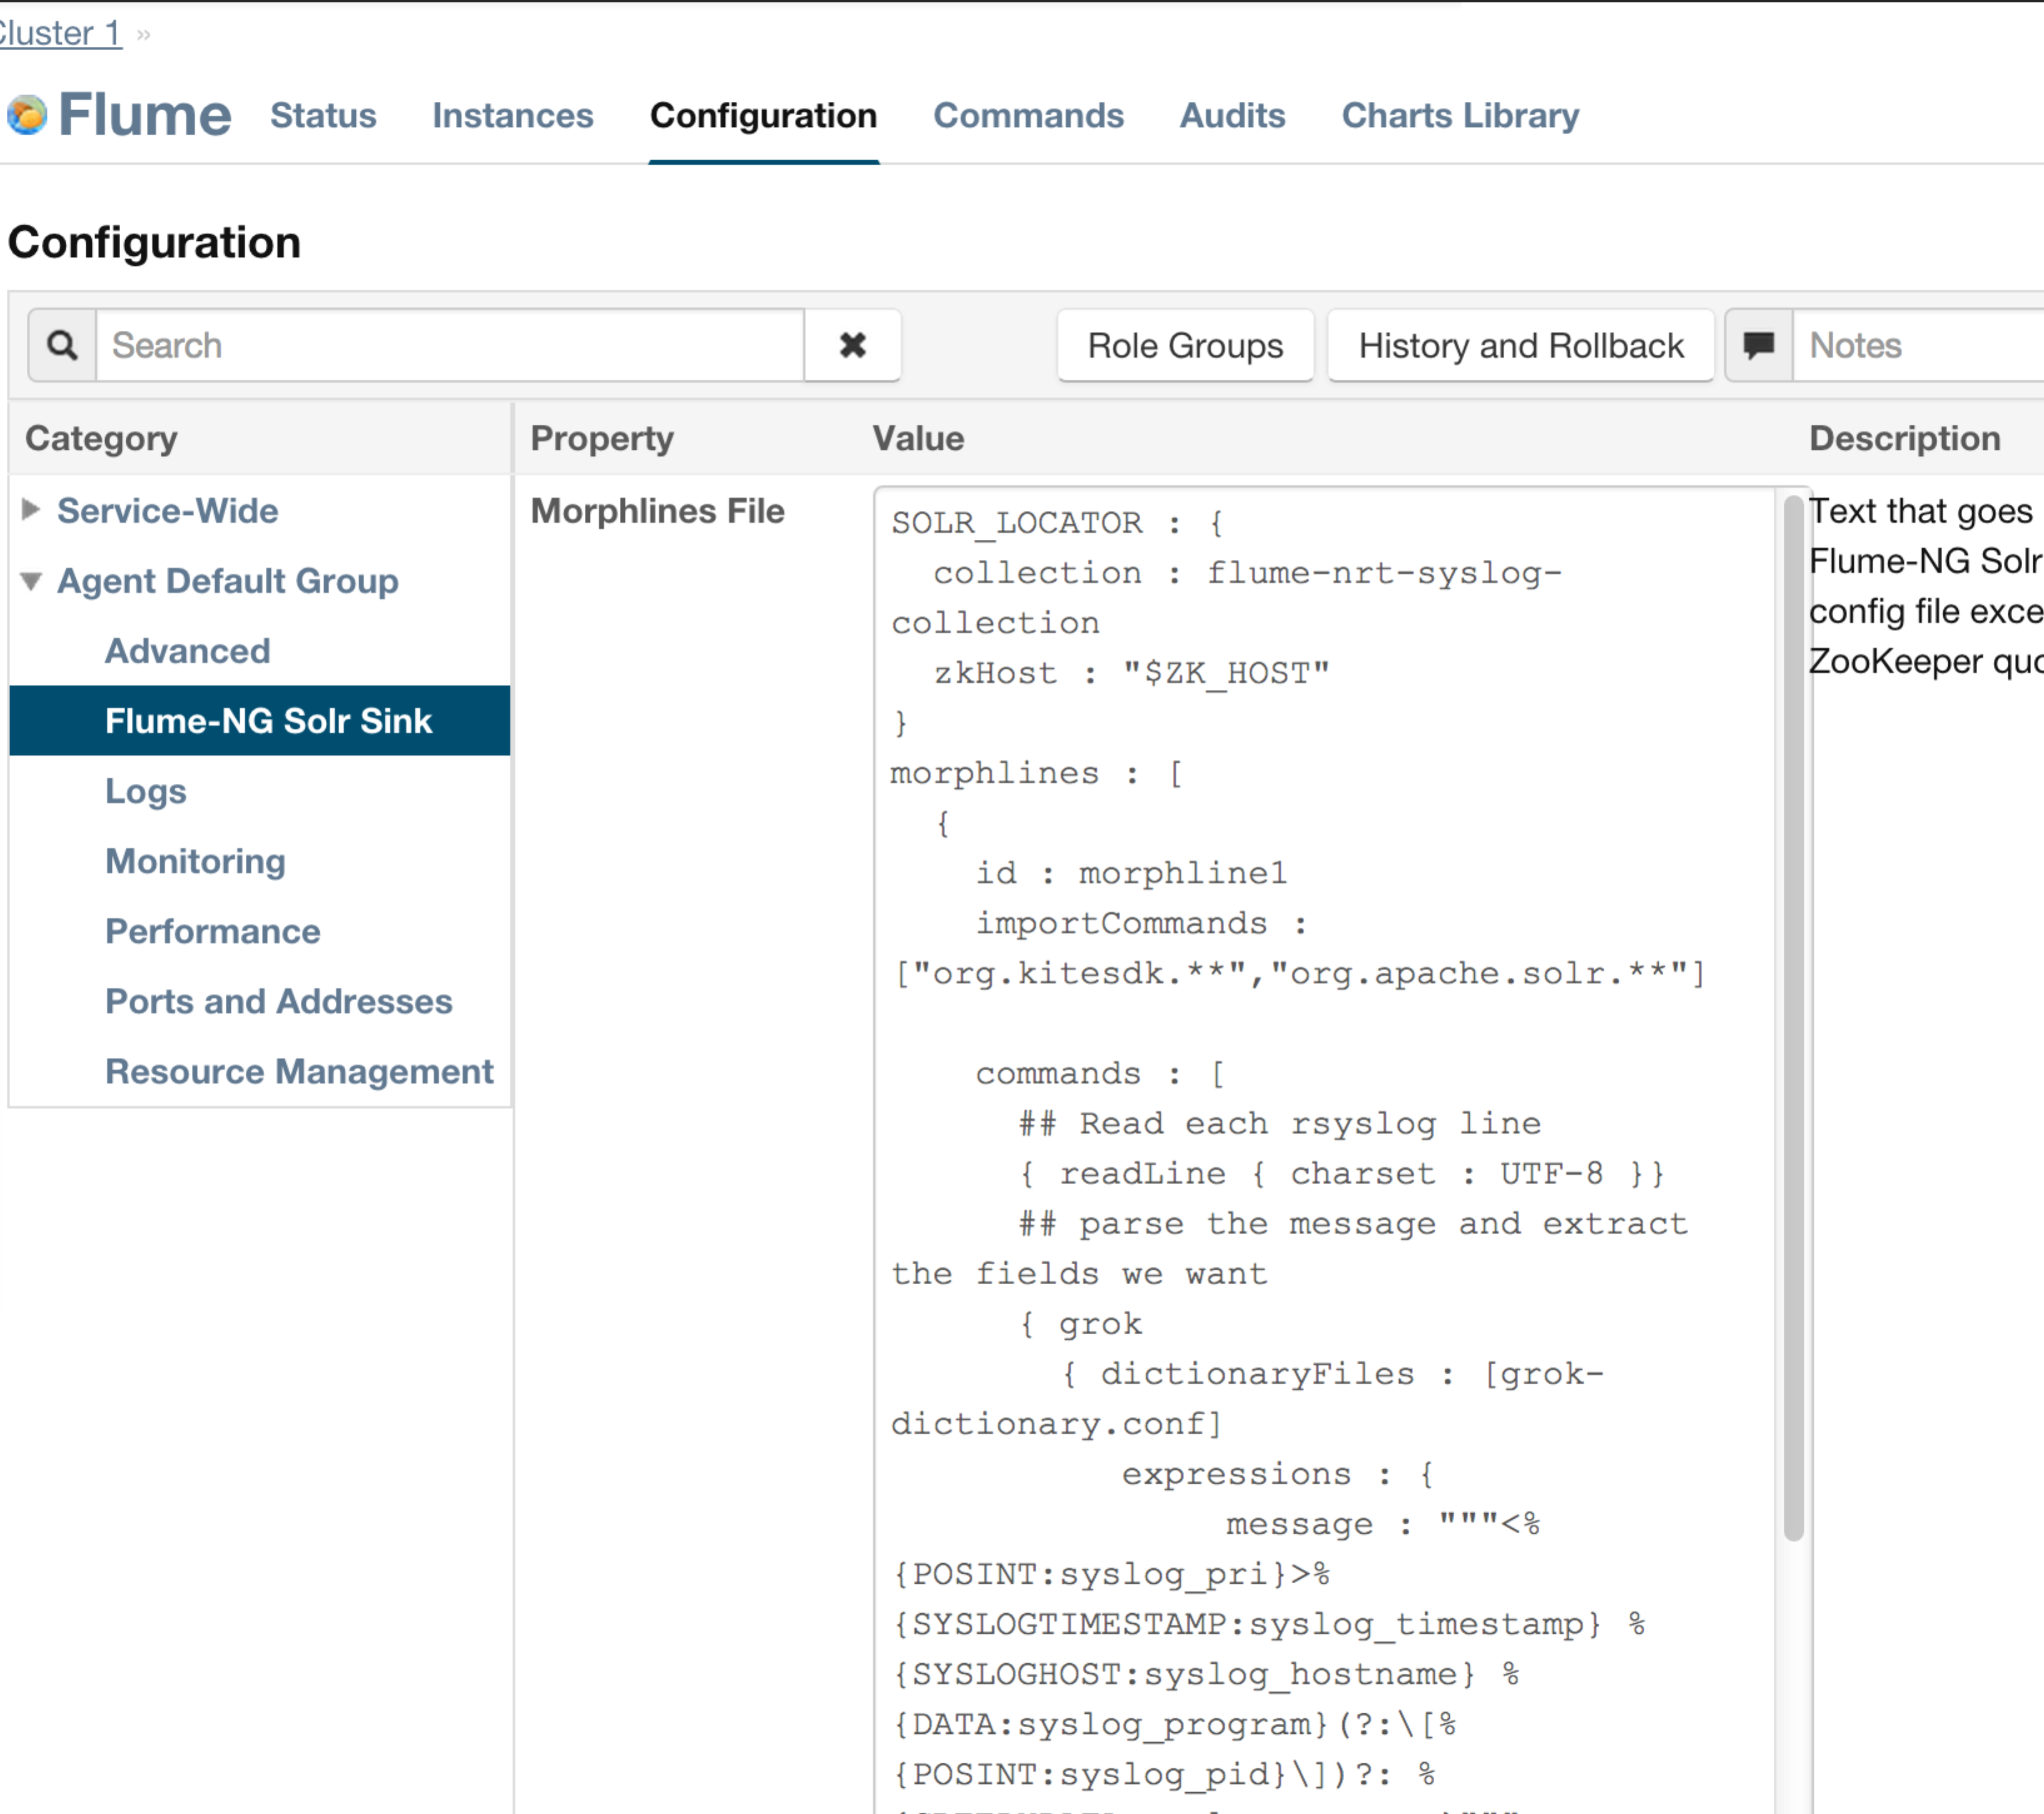

## Restart Flume Service

Restart Flume Service by CM. You can use following command to see the log.

# tail -f /var/log/flume-ng/flume-cmf-flume-AGENT-ip-172-31-12-149.us-west-2.compute.internal.log

# Configure Rsyslog for HDFS NRT Indexer and Search

## Take Rsyslog as an example.

## Configure Rsyslog to forward events to Flume

Edit the forwarding rule in the last section of  /etc/rsyslog.conf as follows (uncomment the first 6 lines, and then make sure to specify the name of the host running your Flume Agent in the last line, as well as port 5144).

# An on-disk queue is created for this action. If the remote host is

# down, messages are spooled to disk and sent when it is up again.

$WorkDirectory /var/lib/rsyslog # where to place spool files

$ActionQueueFileName fwdRule1 # unique name prefix for spool files

$ActionQueueMaxDiskSpace 1g # 1gb space limit (use as much as possible)

$ActionQueueSaveOnShutdown on # save messages to disk on shutdown

$ActionQueueType LinkedList # run asynchronously

$ActionResumeRetryCount -1 # infinite retries if host is down

# remote host is: name/ip:port, e.g. 192.168.0.1:514, port optional

*.* @@**ip-172-31-12-149.us-west-2.compute.internal**:**5144**

# ### end of the forwarding rule ###

## Restart rsyslog service

# service rsyslog restart

# Cloudera Search Result in Solr and Hue UI

## Check Solr Queries

You can check Solr Server Web UI to query the results

<http://ec2-54-68-244-213.us-west-2.compute.amazonaws.com:8983/solr/#/flume-nrt-syslog-collection_shard2_replica1>

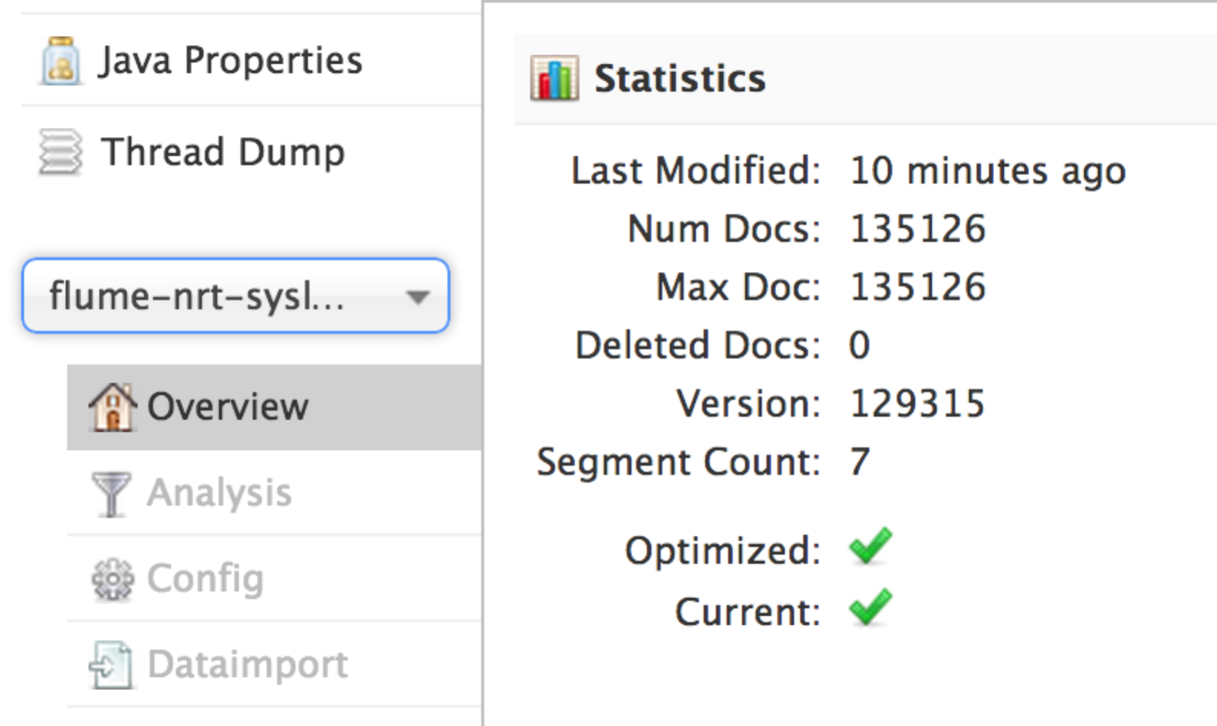

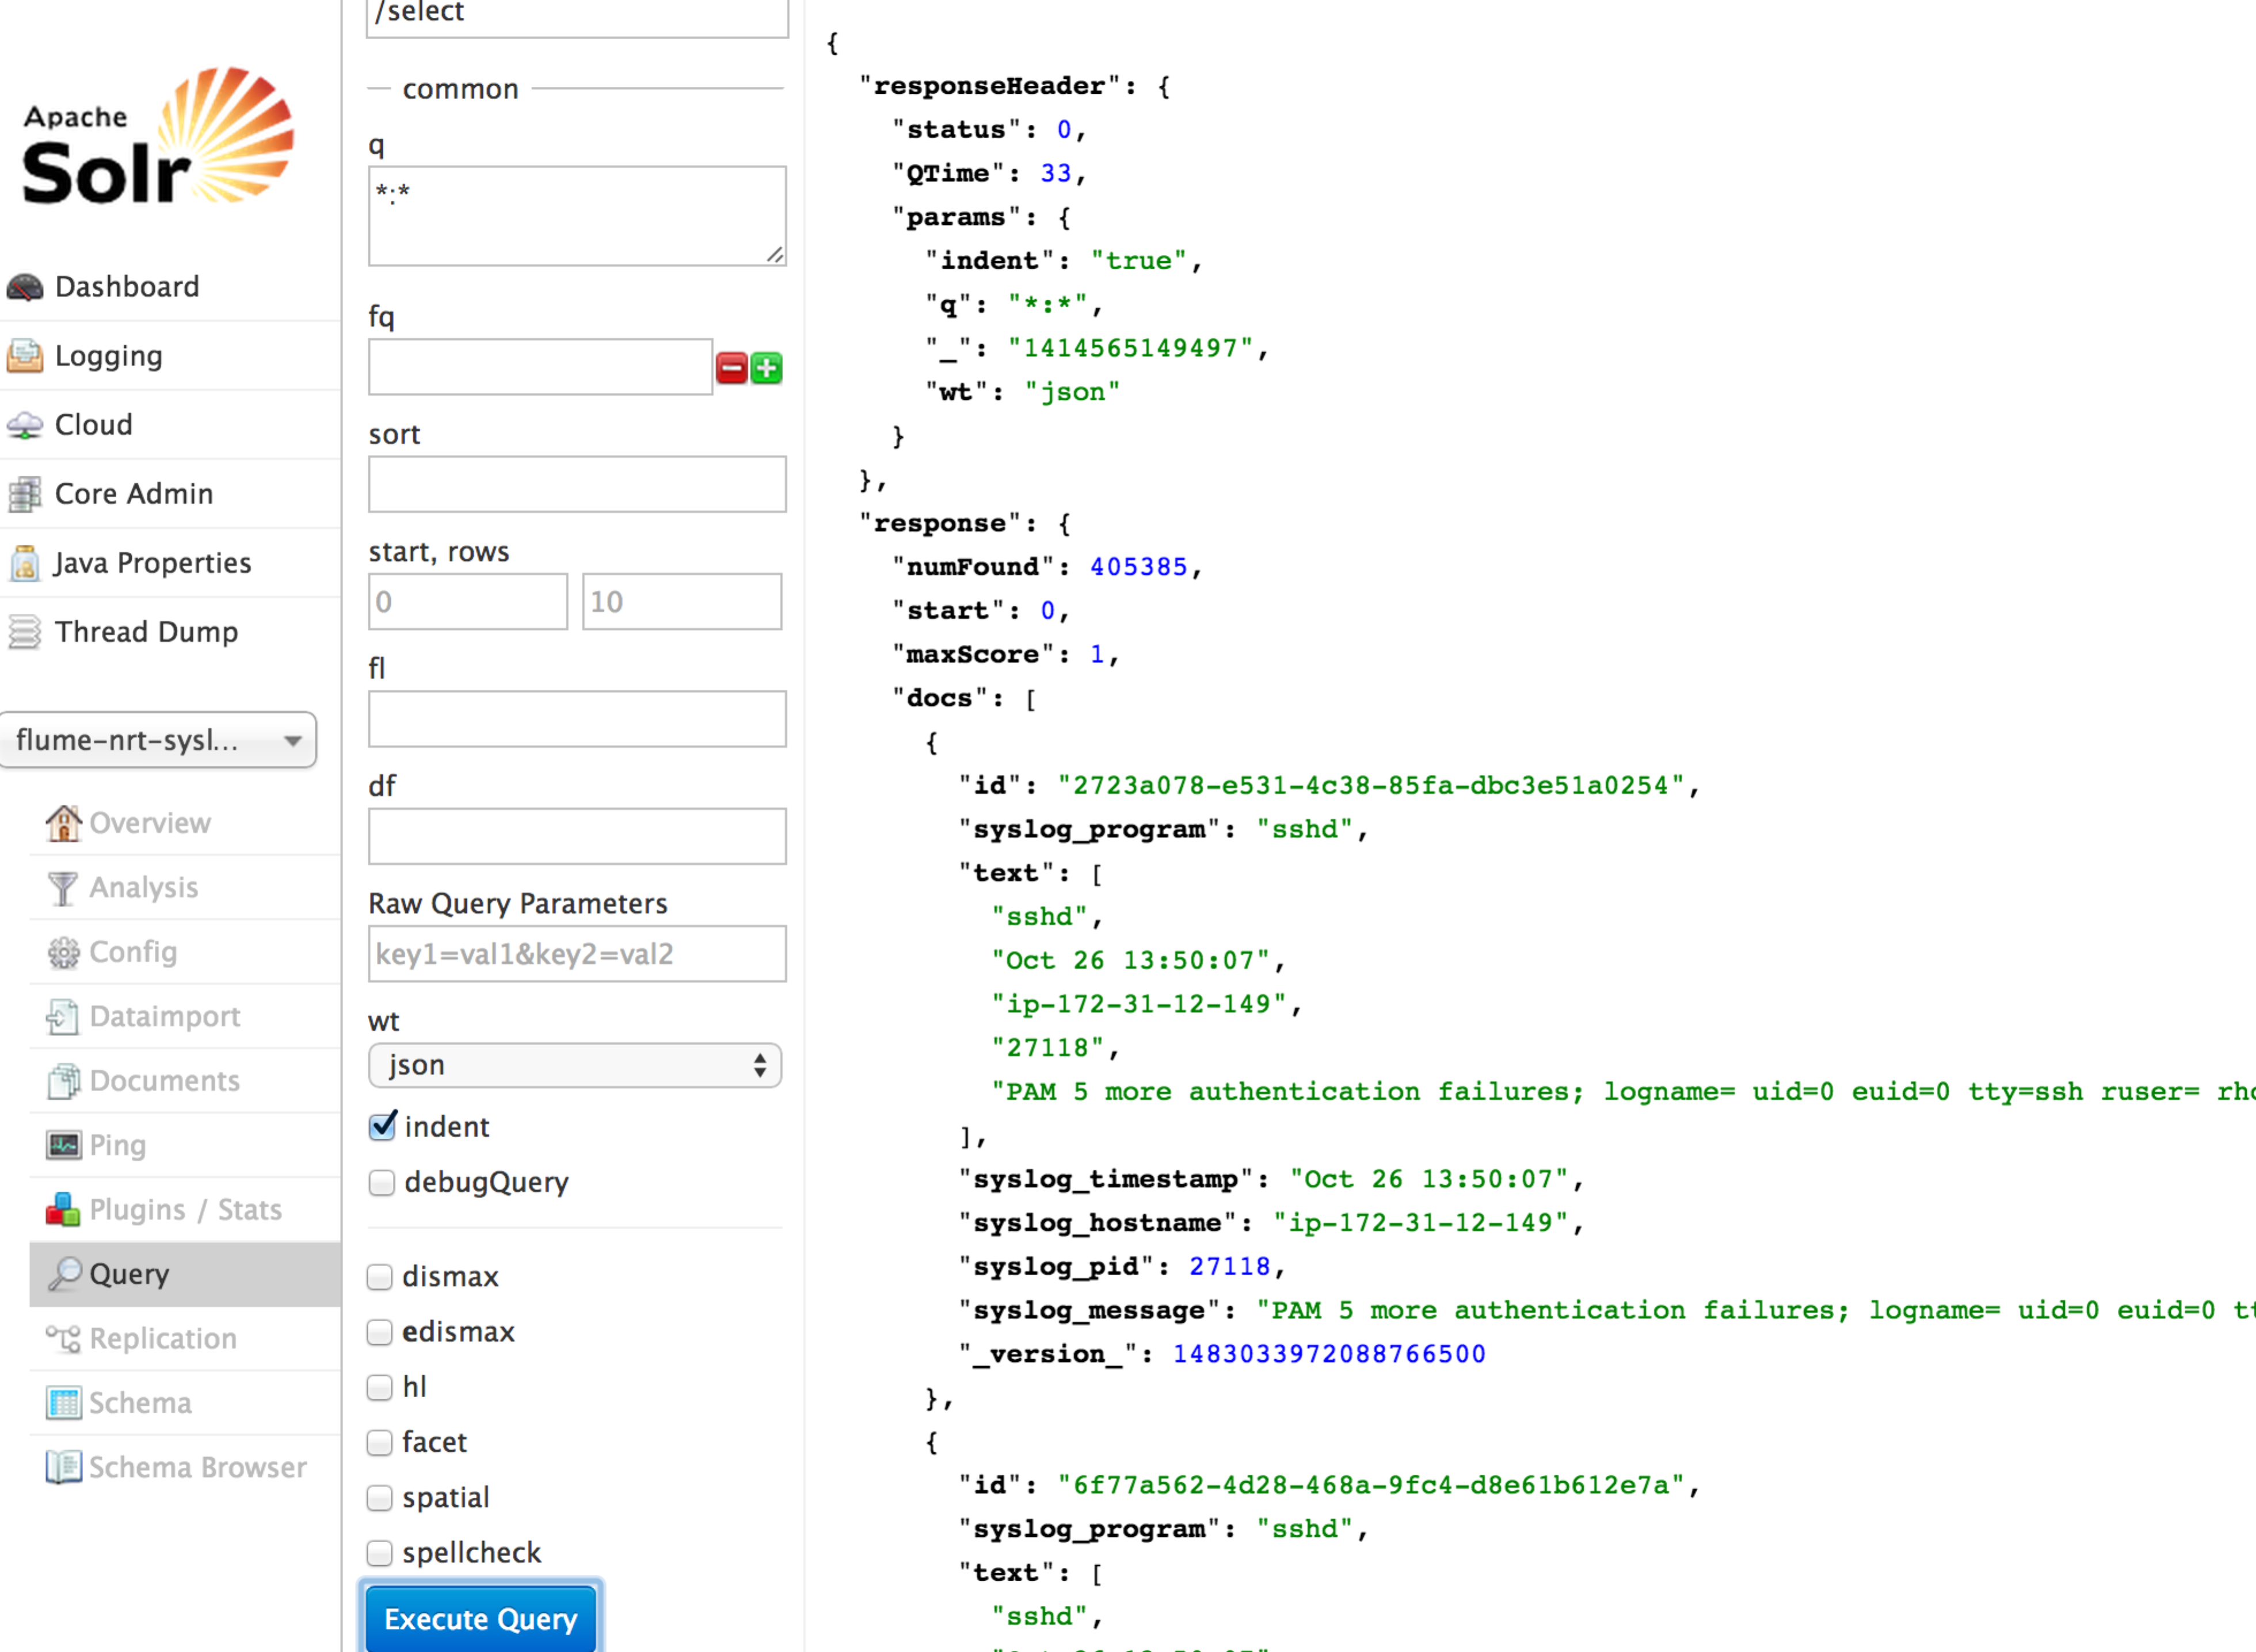

## Hue → Search

Hue 🡪 Search, then you can see all the available collections live in Cloudera Search.

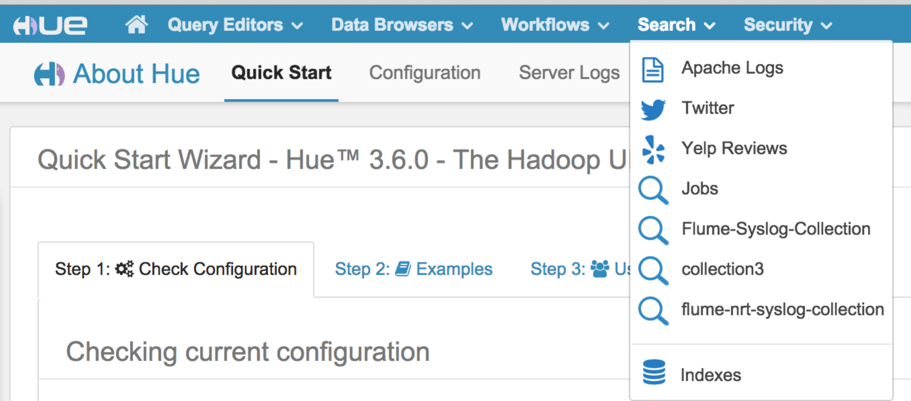

## Hue → Search 🡪 Indexes

Hue 🡪 Search 🡪 Indexes, you can see all the available indexes in Cloudera Search.

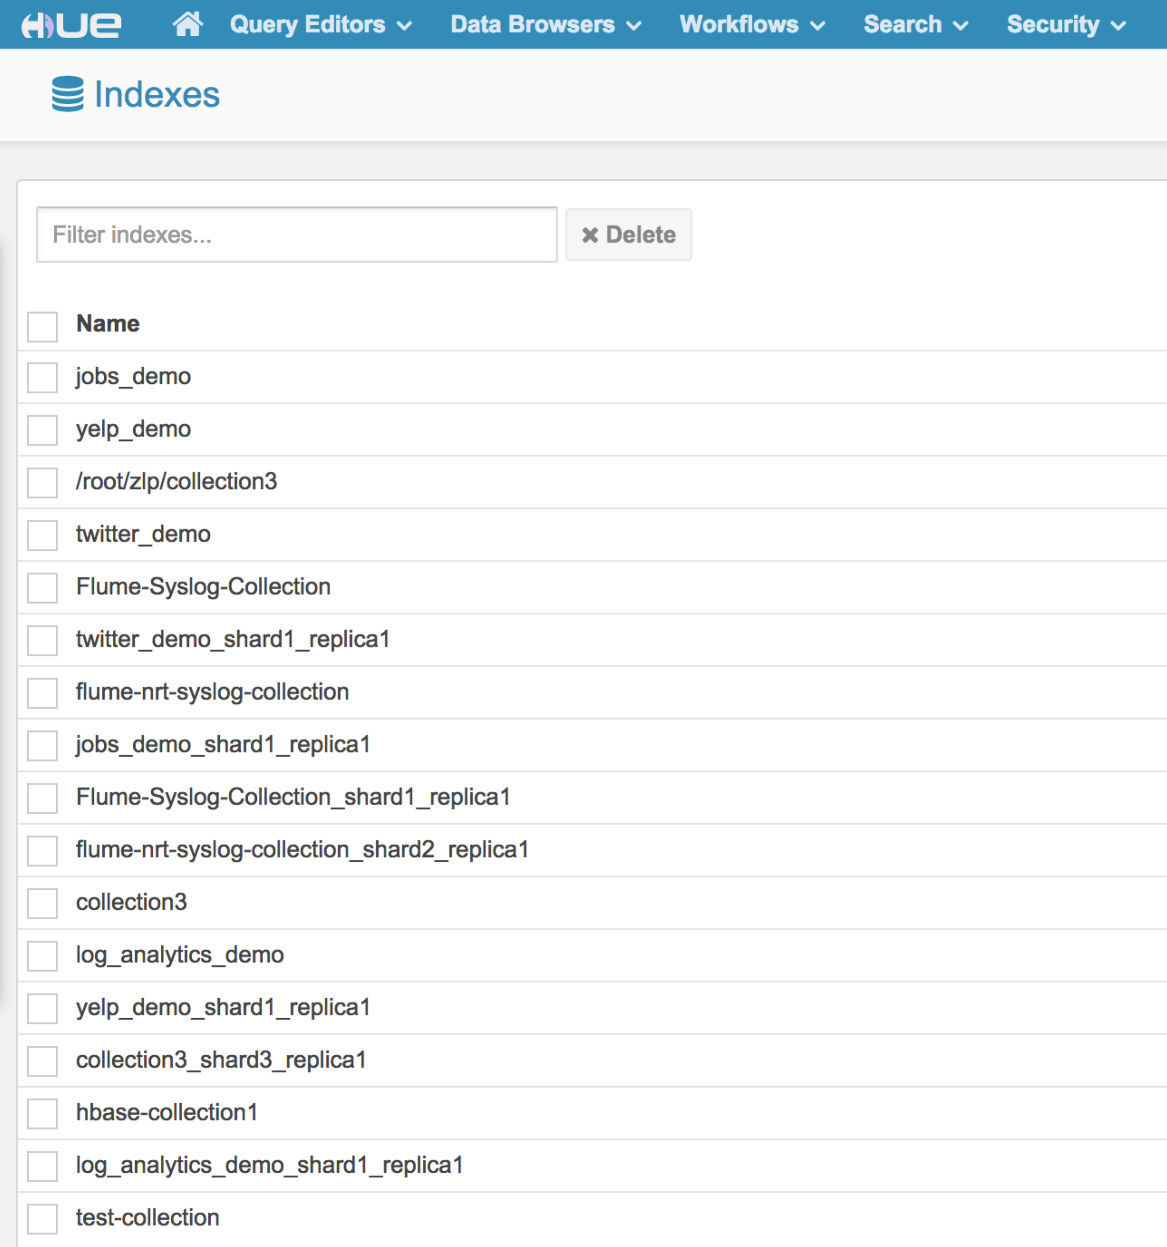

## Hue → Search 🡪 Indexes 🡪 flume-nrt-syslog-collection

Hue 🡪 Search 🡪 Indexes🡪 flume-nrt-syslog-collection, you can see all the available indexes definition for flume-nrt-syslog-collection.

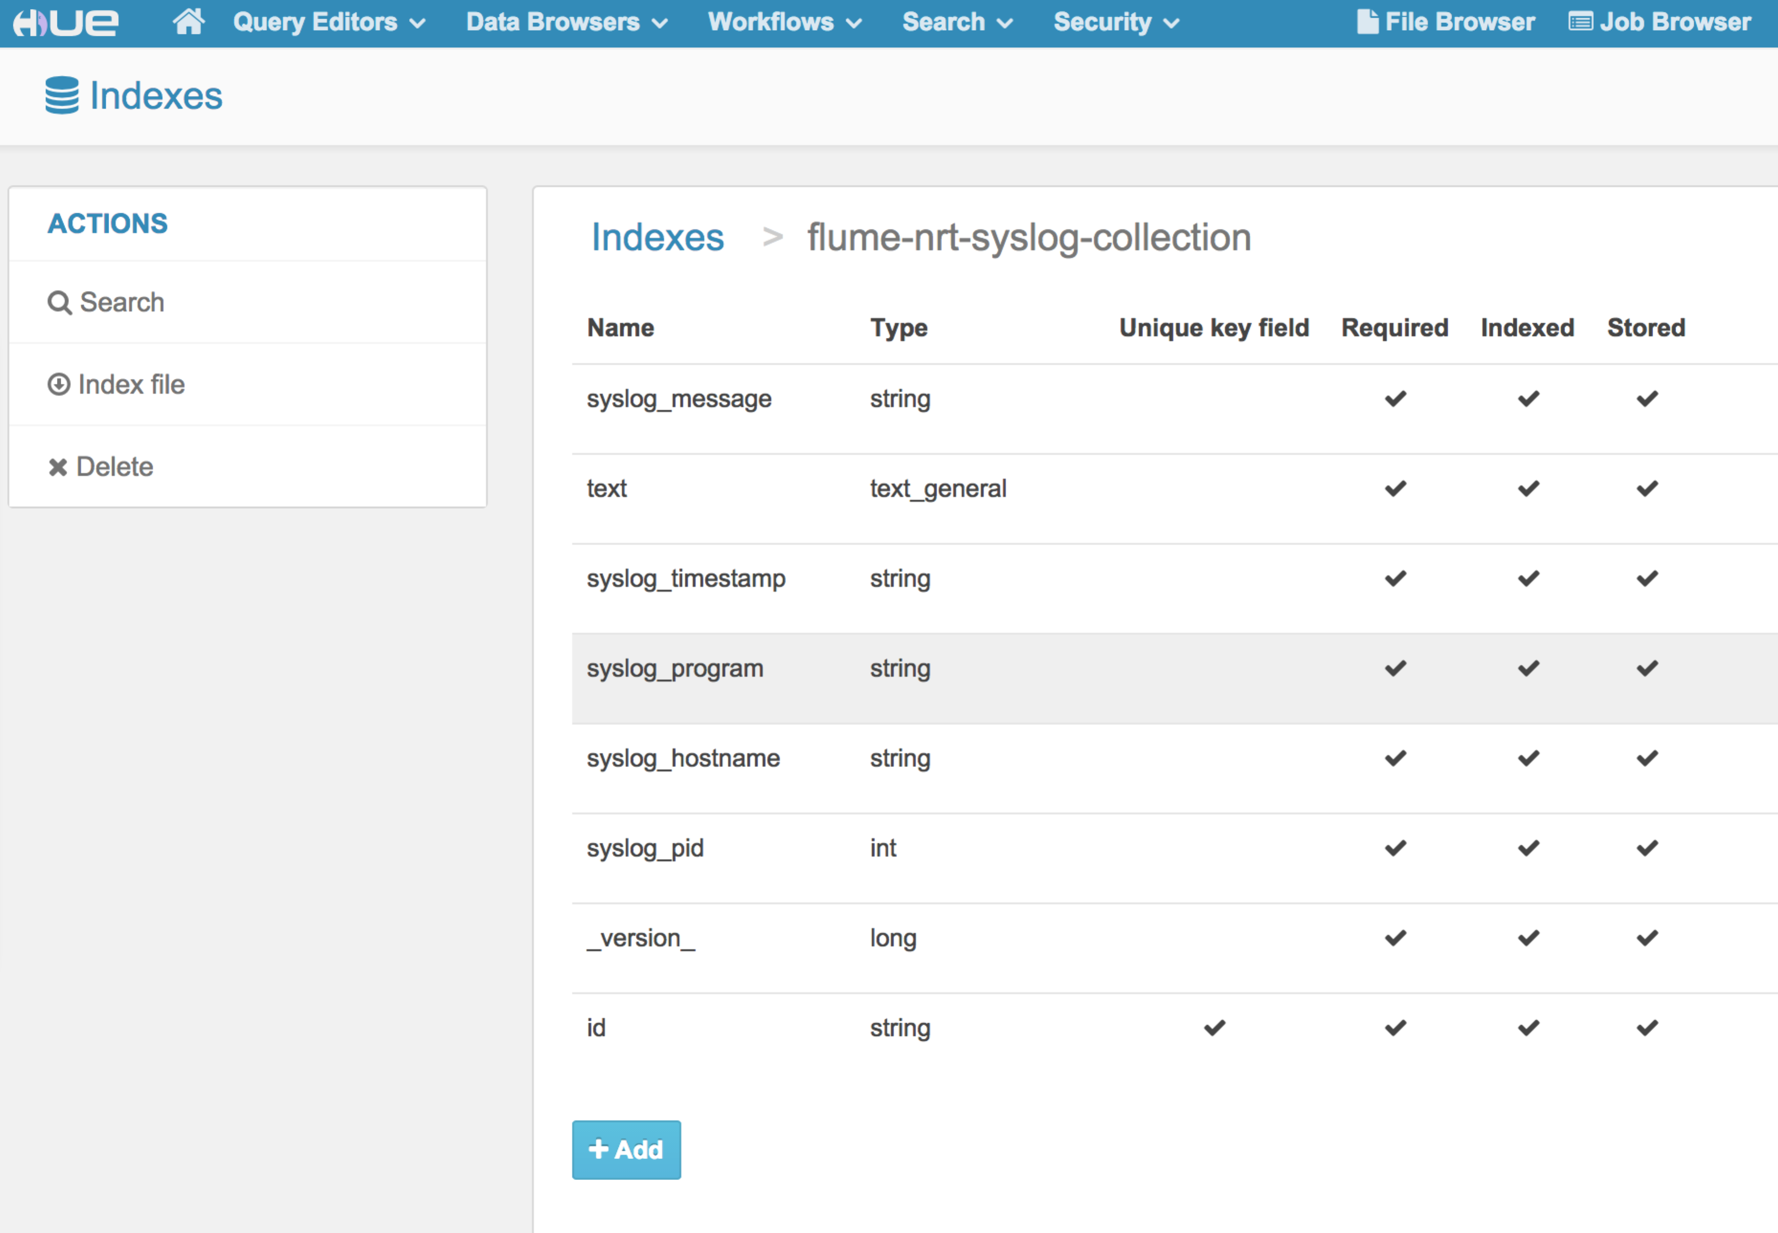

## Hue → Search 🡪 Indexes 🡪 flume-nrt-syslog-collection 🡪 Search

Hue 🡪 Search 🡪 Indexes🡪 flume-nrt-syslog-collection 🡪 Search, you can see the Search Bar and, index Fields, and results for flume-nrt-syslog-collection.

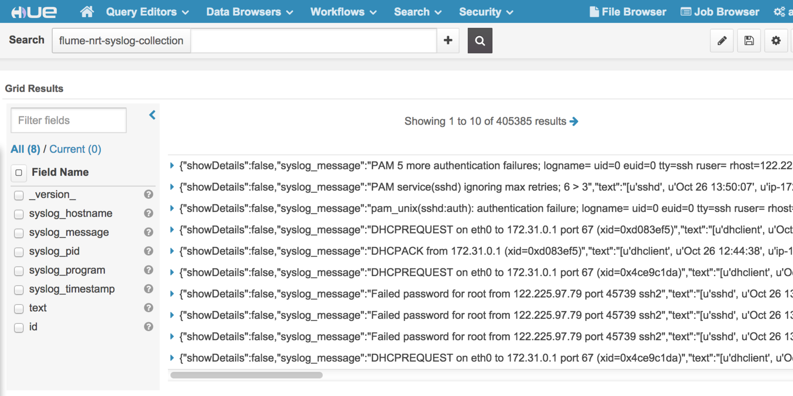

## Verify NRT Indexer and Search

To verify the index is updated in NRT, execute a "logger" command on the host that is forwarding messages like this:

**# logger This is Spinal Tap**

## Search Keyword

Hue 🡪 Search 🡪 Indexes🡪 flume-nrt-syslog-collection 🡪 Search, Search keyword in Search Bar to run full text search, for example: “Spinal”.

You should be able to immediately search for that message.

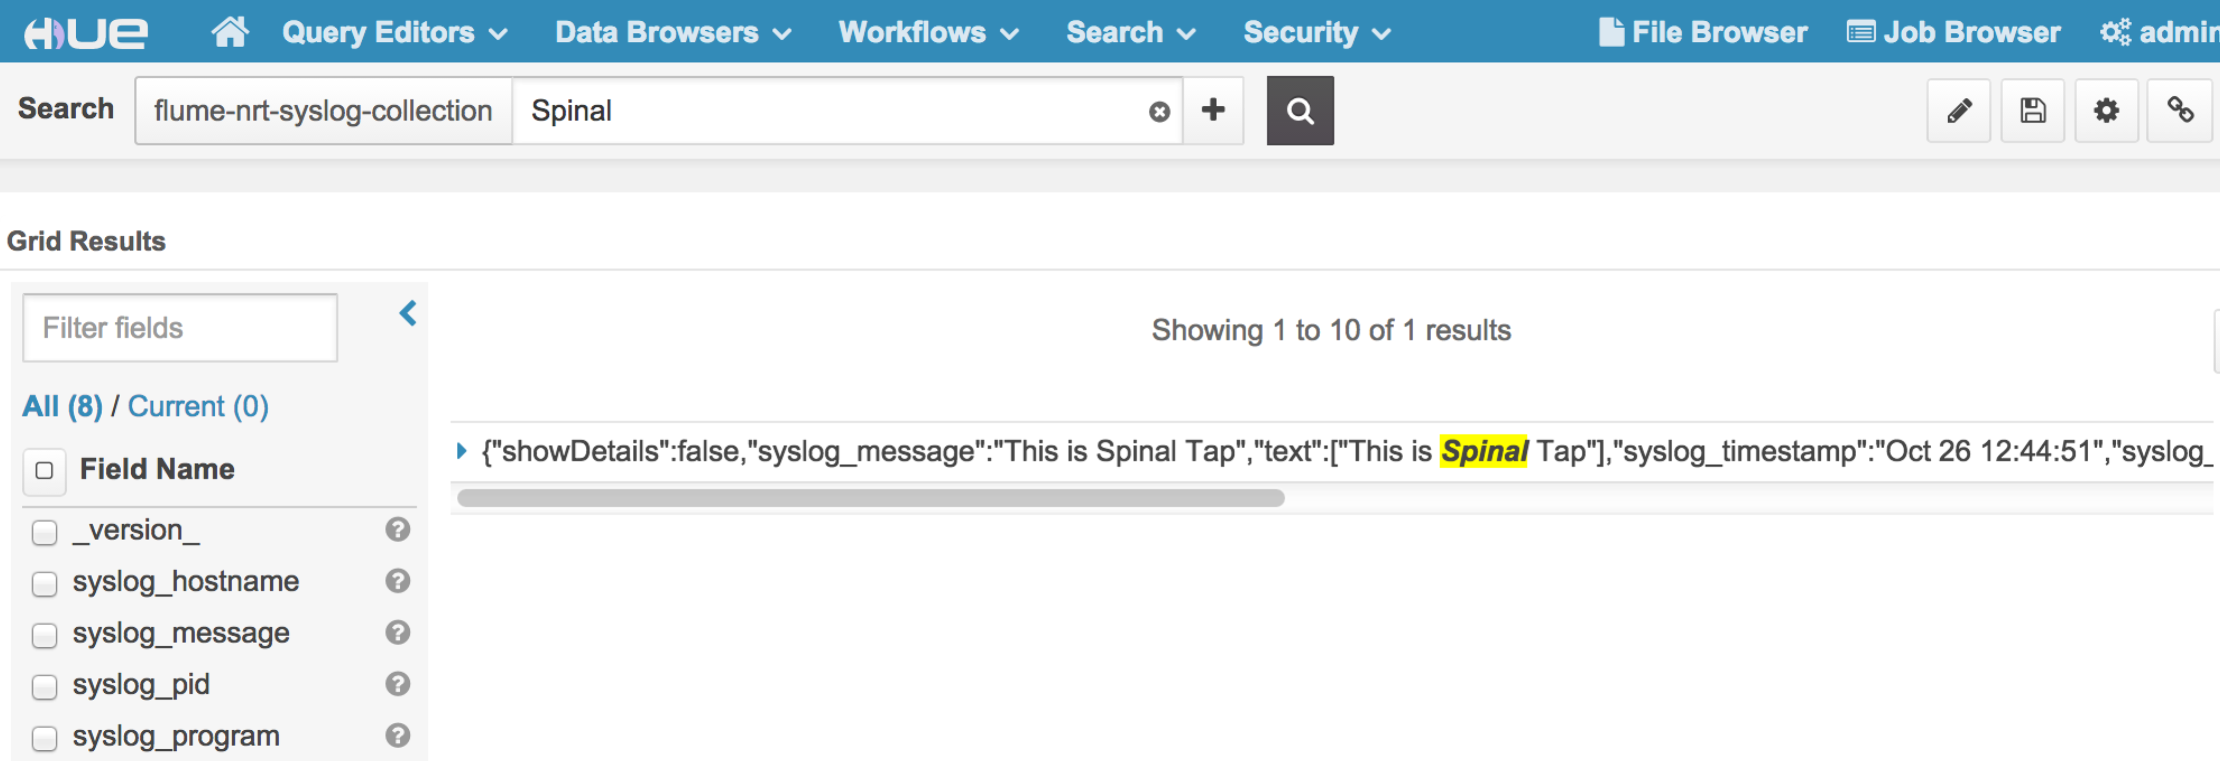

# Design Facets

## Design Facets by Widgets

You can “Edit ” and drag “WIDGETS” for Hostname and Program as facets like this:

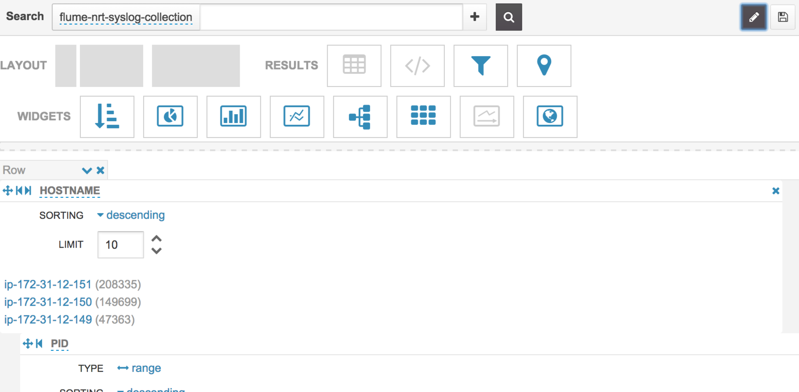

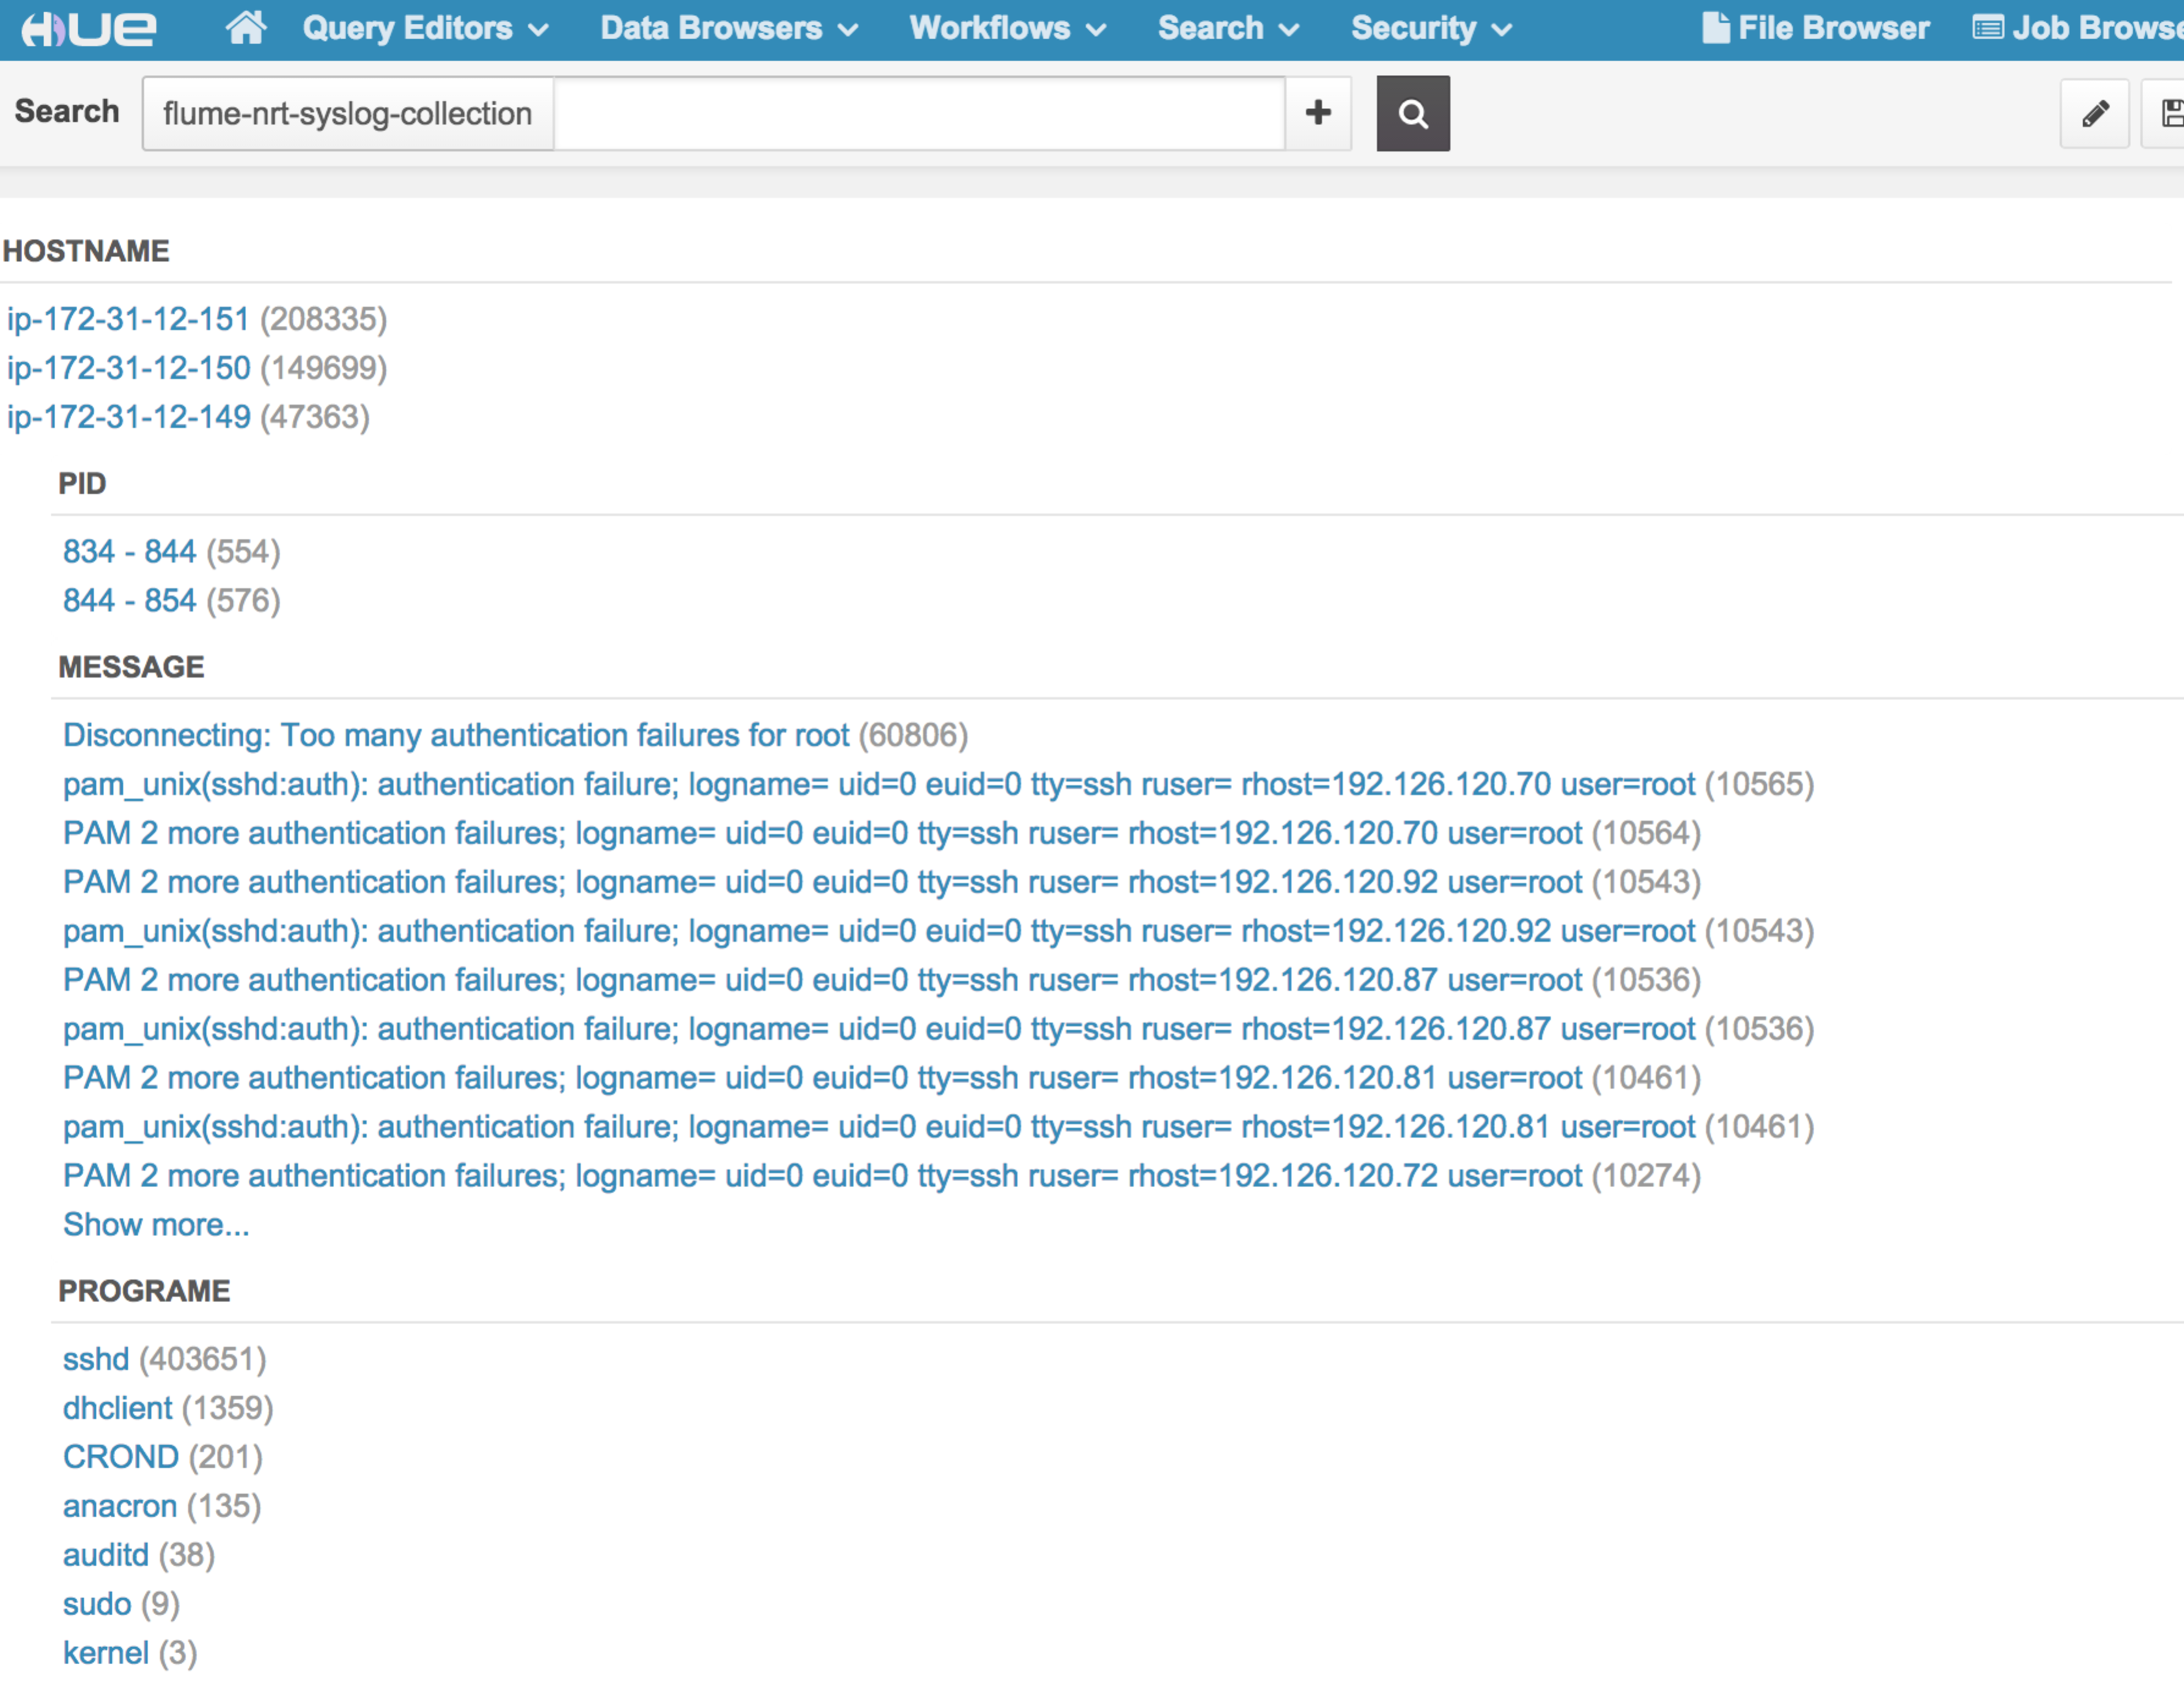

## Hue → Search🡪 flume-nrt-syslog-collection

Hue 🡪 Search 🡪flume-nrt-syslog-collection, you can see the Search Bar and, index Fields, and results for flume-nrt-syslog-collection facets.

You can navigate the search by Hostname and Program.

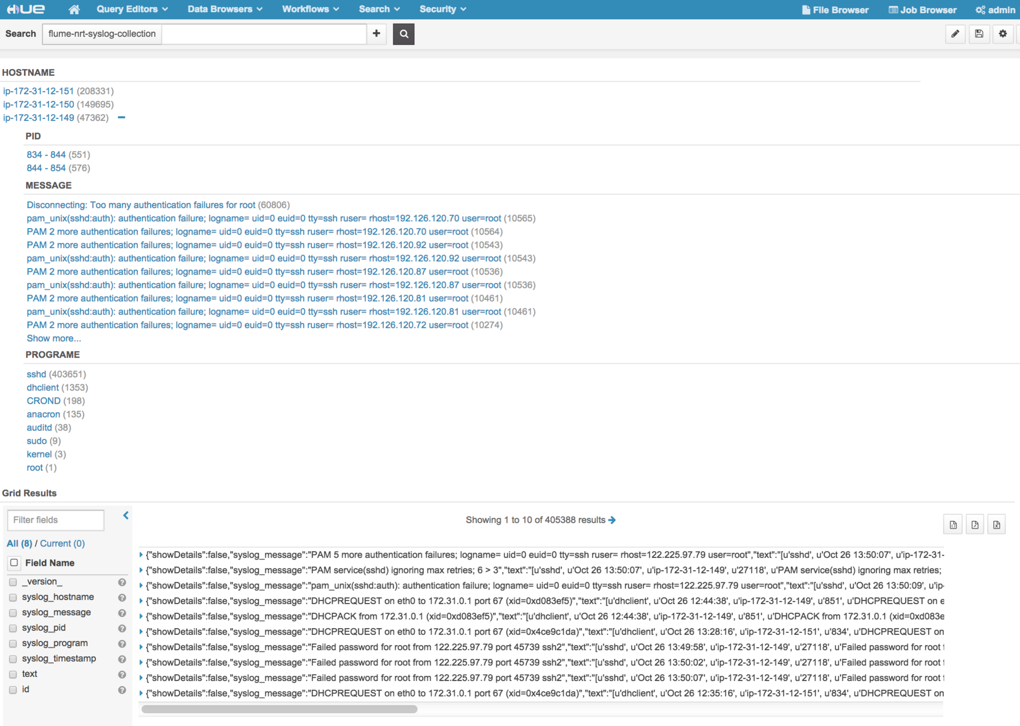

Search by “hostname” and “pid”:

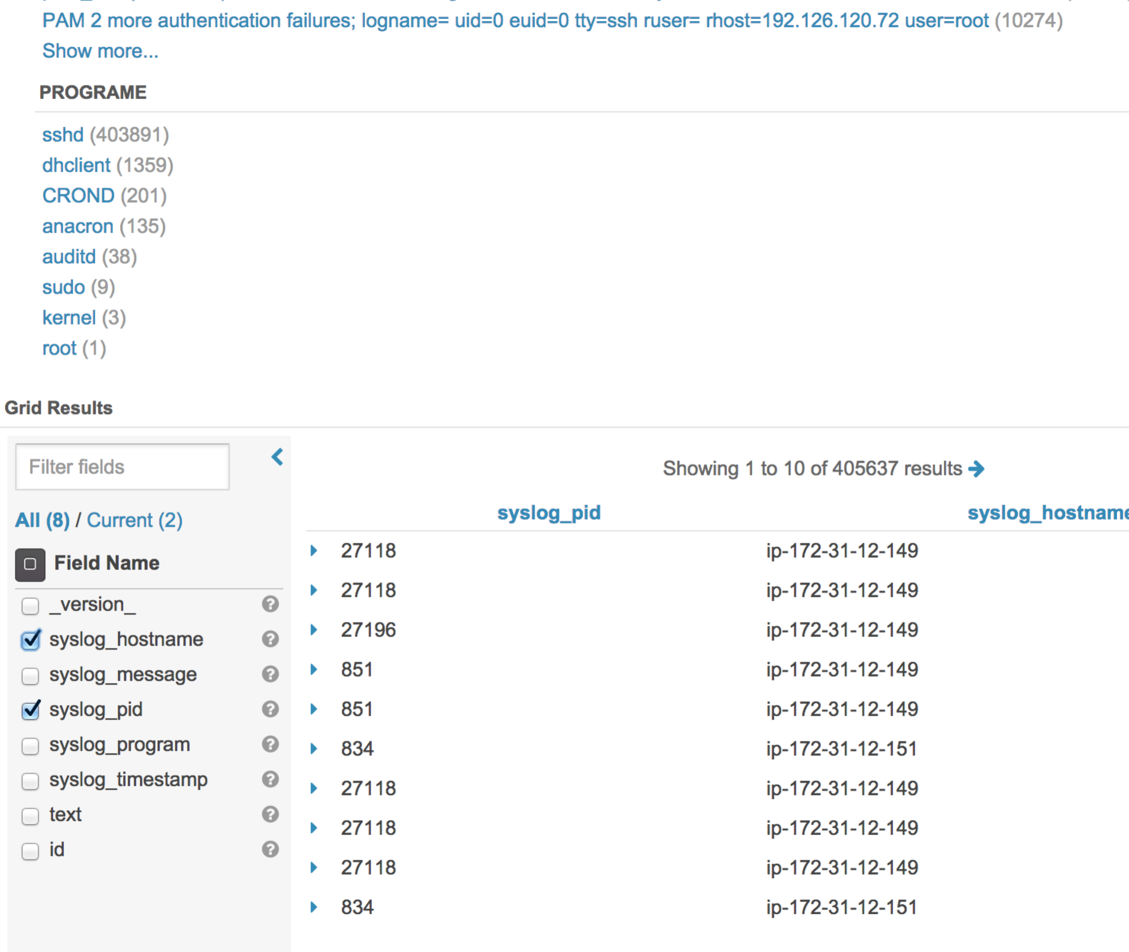

Search “Spinal”:

